Dallas Christian College Assessment Plan
Detailed Explanation for DCC Website: 2025
Introduction
The Dallas Christian College (DCC) assessment plan has evolved over time but still is based on program-level learning objectives that are published for each program in the academic catalog. Following best practices, DCC generally prefers:
- Direct assessments in which students themselves demonstrate their knowledge and skills versus indirect assessments based on hearsay,
- Authentic assessments that call for students to perform real-world tasks rather than artificial assessments found only in a school setting,
- Integrative assessments that measure multiple learning objectives at the same time and in relation to one another—often facilitated by a grading rubric giving attention to each relevant objective,
- Embedded assessments built into an existing course as a learning activity rather than burdening students unnecessarily with an “extra” task outside the educational program,
- Multiple assessments of a given learning objective over single assessments.
The assessment process has two goals: (1) To provide evidence to stakeholders that students completing a DCC program have achieved the program objectives. (2) To identify through data analysis ways student outcomes could be improved and to put the plan, the resources, and the funding in place to seek improved outcomes.
Before presenting the assessment process, it is important to understand some vocabulary used in the DCC system:
"Course-level" learning objectives identify the knowledge, skills, and/or dispositions a student should gain through an individual course.
"Program-level" learning objectives identify the knowledge, skills, and/or dispositions a student should gain through an entire academic program consisting of multiple courses.
In a course, "formative" assignments help students “form” new knowledge or skills. For example, an assignment might call for students to practice a new kind of math problem. Formative assignments usually have less impact on final course grades because students are in the process of learning as they do the assignment.
In a course, "summative" assignments measure the "sum total" of students' learning. They call for students to demonstrate that they have mastered the knowledge or skill developed through the formative assignments. For example, the final exam in a math course would be a summative assignment. Summative assignments carry more weight in determining students' final course grade because they measure how well students have achieved the course-level learning objectives.
DCC regularly uses a single summative assignment to assess student learning at both the course level and the program level. This is called an "embedded assessment"—that is, a program-level assessment embedded within a course.
Instructors usually grade such assignments based on a rubric, which calls for them to assess multiple aspects of the assignment. For example, in one part of the rubric, instructors may assess the quality of a student's written research paper. In another part of the rubric, they assess how well the student communicated results of that research in an oral presentation.
A students' course-level "grade" and program-level "assessment" are not necessarily the same. This distinction is especially important due to DCC's frequent use of course-embedded assessments. For example, at the course level, instructors may apply all parts of the grading rubric to the written/oral assignment mentioned above in order to make course-level assessments of student performance. However, at the program level, faculty may use the same assignment to measure not students' writing skills or oral skills, but the quality of their critical thinking skills. At the course level, the grading rubric may include whether students follow the parameters of the assignment and whether the writing meets standards of grammar, style, and composition. For the program-level assessment, the proper use of commas and colons does not bear on whether the work demonstrates good critical thinking skills. Therefore, the course grade for the work might be a “B,” but the assessment score indicates exemplary critical thinking skills.
Another important vocabulary nuance is the difference between the program-level learning objective and the student learning outcomes. The objective describes a knowledge or skill the student should have at the end of the program of study. The outcome shows the student accomplished that objective.

The Assessment System
This explanation will use the General Education (GenEd) program assessment as an example to describe this process. The curriculum of the GenEd program was reviewed and revised and the current assessment plan will be used for the first time in 2025. The first line illustrates the process.
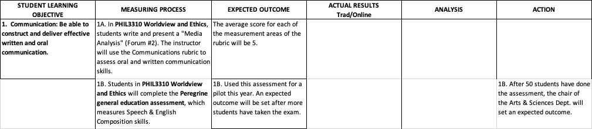
The first column lists the program-level learning objective. All the objectives in the program are listed in the DCC catalog. The second column has two methods to measure how well the student has reached that objective. This follows the best practice of multiple measurements. The first measurement is a course-embedded assessment in the capstone course of the GenEd program. The instructor will use a specific rubric to assess the students’ communication skills. The second measuring process is a third-party, nationally normed, general education assessment that evaluates students’ speech and English communication skills. The third column describes a satisfactory outcome from the communications rubric—that is, the benchmark of performance set by the faculty. The fourth column provides the data on how the students performed (i.e. the learning outcome). This data will be disaggregated by delivery: traditional classroom or asynchronous online. The fifth column provides space for the departmental chair and faculty to analyze the data to tease out any action that should be recorded in the last column.
As soon as resources are available, the department chair will implement the action and review the change the following year to determine whether the change improved the outcomes. In some cases, it could take two years to legitimately assess whether there has been improvement or not. This could happen if needed resources are not available or if the classes are small enough that two years of data are needed to come to a valid conclusion.
Though course-embedded assessments may be the most common way program-level learning objectives are evaluated in the DCC assessment system, it is not the only method used. For example, every baccalaureate program requires an internship. The internship provides a good setting for assessments that are both direct and authentic.
The teacher education program at DCC is different from the other undergraduate programs in that the assessment is determined based on Texas state requirements. Therefore the report for those programs simply reflects the state evaluation.
Newer Programs
The newer programs, including the Sports Science programs, the Master of Transformative Ministry (MTM), and the Master of Transformative Leadership (MTL) are so new that the program assessments have not been worked through completely. They do have one similar characteristic that distinguishes them from the previous programs discussed. These programs have three times (or more) the number of program-level learning objectives. Rather than four to six objectives, they have twelve to nineteen objectives. They will use a similar method of assessment as the older programs, using a matrix in a spreadsheet to describe how the objective will be assessed. The first two program-level student learning objectives in the MTM assessment plan are shown below to illustrate.
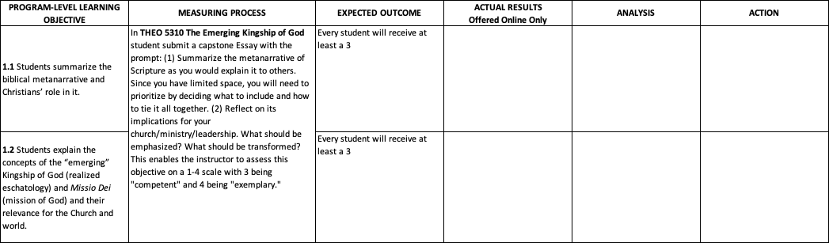
Note the first two objectives are assessed with one course-embedded assignment and rubric. Also noteworthy is that these objectives are typically assessed with only one measurement. There are two reasons for this. There are so many program objectives that it would be cumbersome to have multiple measures. It is also because of the newness of the programs. As assessment goes forward, it may become clear that other assessments are needed to sort out why students are not doing well on an objective.
The other new programs are graduate programs that are all competency-based, direct assessment programs. Rather than a list of learning objectives, those programs provide a list of competencies students will master to complete the program. The students must demonstrate mastery for every competency in order to graduate from the program. Improving these programs will be based on recording data on how long students take to master a competency, how many students pass the competency on the first assessment, and how long students take to graduate from the program.

